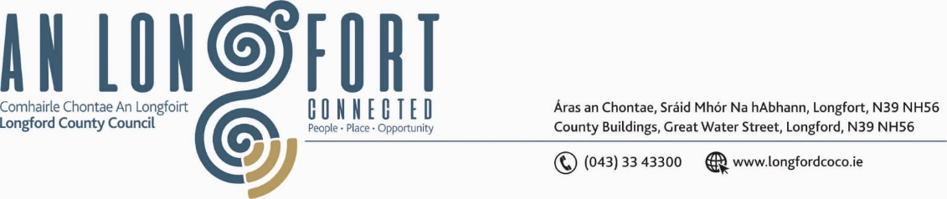

***BALLYMAHON MUNICIPAL DISTRICT***

***Please note meeting will be held in Ballymahon Library.***

**15 February 2024**

**To: Each Member of Ballymahon Municipal District.**

**Dear Member,**

You are requested to attend a Meeting of Ballymahon Municipal District to be held

**in Ballymahon Library** on **Thursday 22 February 2024 at 4pm** to transact business, as set out on the agenda hereunder.

**Yours sincerely**,

_______________

**Claire McNabola,**

**Meetings Administrator.**

**AGENDA**

Prayer before meeting.

1. Confirmation of Minutes
2. Ballymahon Municipal District Meeting held on the 7 December 2023 – enclosed.

**2.** Matters arising from Minutes

**3.** Declaration of Interest by Members

**4**. Management Report – enclosed

**5.** Town Twinning Report

**6**. Community Grants Support Scheme

**7.** Consideration and adoption of Draft Municipal District Report for inclusion in

Longford County Council 2023 Annual Report

**8**. Consideration of PART 8 – NO. 115 Change of use and renovation of existing derelict building known as Mahon’s on Main St. Edgeworthstown to a charity shop and social enterprise and all ancillary site works at the townland of Edgeworthstown services and associated site works

**8.** Notices of Motions, submitted by Councillors, as listed hereunder –

**Councillor Paul Ross**

1. That Longford County Council apply for a low-cost safety scheme at the townland of Aghintemple/Killenastra, Ardagh on the R393 to install a crash barrier on the dangerous bend where there have been many crashes including a crash in which a vehicle hit a house and burned it down.
2. That Longford Co Council in conjunction with The OPW reinstate the timber post and rail fence at the Royal Canal, Terlicken, Ballymahon as the existing fence has blown down.
3. That a pedestrian crossing be installed at junction of The Park House Hotel and Kilbride Park in the interest of public safety.

**Councillor Pat O’Toole**

1. I call on Longford County Council to upgrade the lighting over the pedestrian crossing at St. Matthew’s Church Ballymahon similar to what is provided at the pedestrian crossing at St.Matthew’s Primary School.
2. I call on Longford County Council to carry out an assessment of St.Anne’s Housing Estate off Main Street  Ballymahon (6 houses) with a view to carrying out a deep retrofit of same.